164122M-S.I Sandeepanie

164124V-S.A.H.C Senanayaka

Semantic and Ontological Modelling

Assignment 2

# Classes and their instances

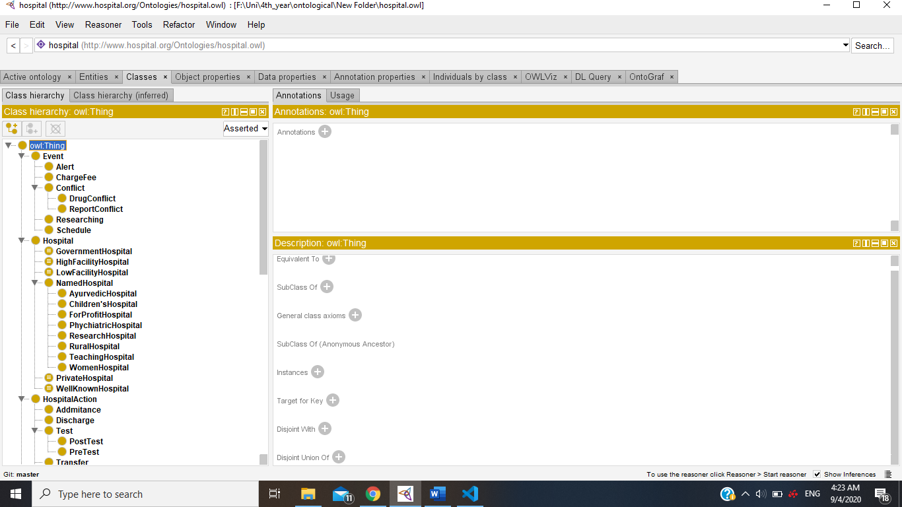

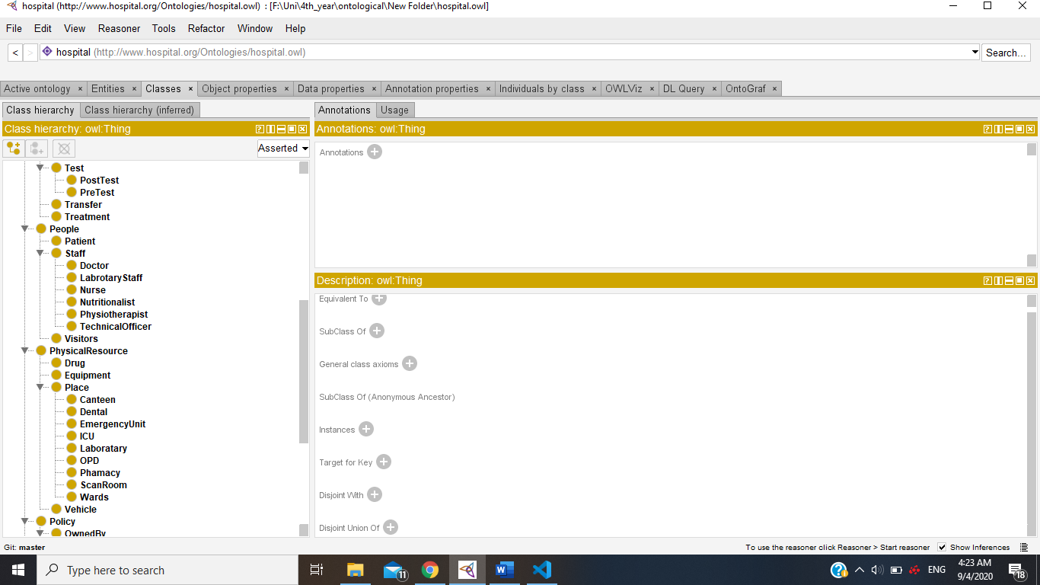

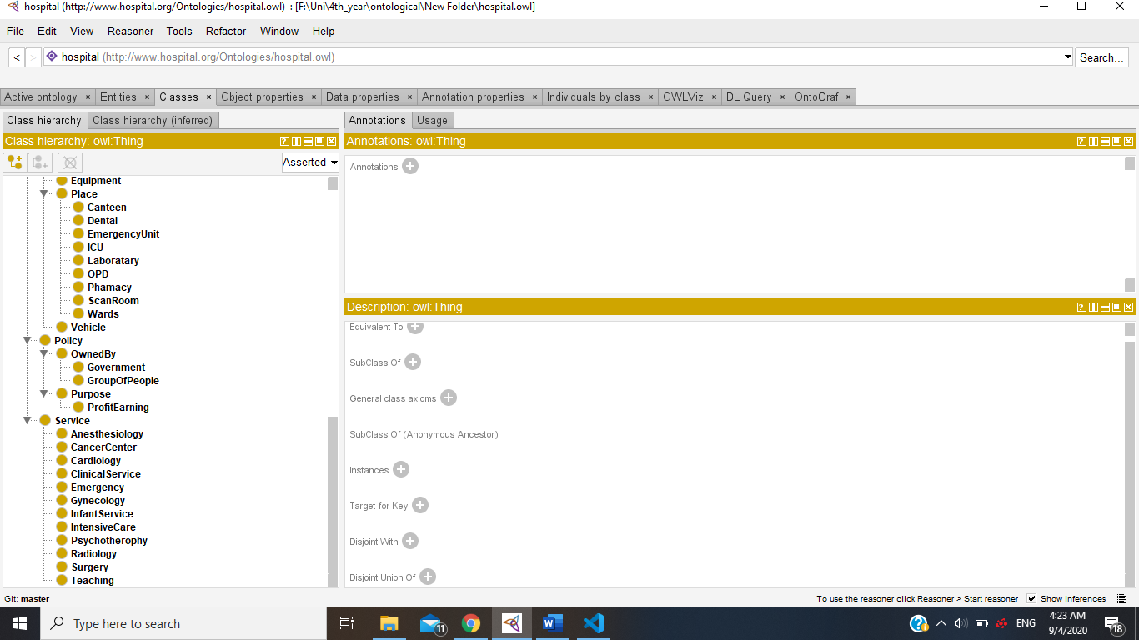

Instances of class PhysicalResource

:Ambulance rdf:type owl:NamedIndividual .

:CTScanner rdf:type owl:NamedIndividual .

:Capsules rdf:type owl:NamedIndividual .

:Inhalers rdf:type owl:NamedIndividual .

:Injections rdf:type owl:NamedIndividual .

:ECG rdf:type owl:NamedIndividual .

:Liquid rdf:type owl:NamedIndividual .

:MRIScanner rdf:type owl:NamedIndividual .

:PulseOximeter rdf:type owl:NamedIndividual .

:Stethoscope rdf:type owl:NamedIndividual .

:Thermometer rdf:type owl:NamedIndividual .

:Ventilator rdf:type owl:NamedIndividual .

:SurgeryEquipments rdf:type owl:NamedIndividual .

:Tablet rdf:type owl:NamedIndividual .

Instances of class ?

:Dentist rdf:type owl:NamedIndividual .

:EyePhysician rdf:type owl:NamedIndividual .

:HeartPhysician rdf:type owl:NamedIndividual .

:Surgeon rdf:type owl:NamedIndividual .

Instances of class Doctor

:HasiniJayasekara rdf:type owl:NamedIndividual ;

:IsharaPerera rdf:type owl:NamedIndividual ;

:JamesAndrew rdf:type owl:NamedIndividual ;

:PiyumiDissanayaka rdf:type owl:NamedIndividual ;

Instances of class Hospital

:LakdiwaWikramasekaraAyurvedicHospital rdf:type owl:NamedIndividual ;

:LankaHospital rdf:type owl:NamedIndividual ;

:NationalHospitalOfMentalHealth rdf:type owl:NamedIndividual ;

:SethmaHospital rdf:type owl:NamedIndividual ;

:KarapitiyaHospital rdf:type owl:NamedIndividual ;

:LadyRidgwayHospital rdf:type owl:NamedIndividual ;

:TeachingHospitalPeradeniya rdf:type owl:NamedIndividual ;

Instances of class Patient

:MalaniKetagoda rdf:type owl:NamedIndividual ;

:SabadaKaluarachchi rdf:type owl:NamedIndividual ;

:SarangaAlahapperuma rdf:type owl:NamedIndividual .

:SenakaBatasena rdf:type owl:NamedIndividual ;

:SunilMendis rdf:type owl:NamedIndividual ;

:ZaharaMalhothra rdf:type owl:NamedIndividual ;

# Object type Properties

If a property relates individuals to individuals, then it is object property

Procedure

# Functional properties

this means that for any given individual, the property can have at most one value

:Patient :admittedTo :Hospital

# Inverse Functional properties

 this means the inverse property of the selected property (whether it explicitly declared or not) is Functional. In other words, there can be at most one incoming relationship along the property for that individual

# Non Functional properties

this means that for any given individual, the property can have at more than one value

:Hospital :hasPhysicalResources :PhysicalResource

# Transitive Properties

this means that if individual x is related to individual y, and individual y is related to individual z, then individual x will be related to individual z.

# Symmetric Properties

this means that the property has itself as an inverse, so if individual x is related to individual y then individual y must also be related to individual x along the same property.

# Asymmetric Properties

this means that if individual x is related to individual y then individual y is not related to individual x along the same property.

# Reflexive Properties

 Asserting that a property is reflexive causes every single individual to be related to itself via that property.

# Irreflexive Properties

Asserting that a property is irreflexive means that an individual cannot be related to itself via that property.

# Data Type properties

if property relates individuals to literals, then it is a datatype property.

* :hasAdmittedDate rdf:type owl:DatatypeProperty .

:ZaharaMalhothra :hasAdmittedDate "2020-04-21"^^xsd:string .

* :hasBeds rdf:type owl:DatatypeProperty

:KarapitiyaHospital :hasBeds 1200 .

:LakdiwaWikramasekaraAyurvedicHospital :hasBeds 100 .

* :hasEmail rdf:type owl:DatatypeProperty .
* :hasHospitalChair rdf:type owl:DatatypeProperty .
* :hasWardNumber rdf:type owl:DatatypeProperty .
* :isHospitalPhone rdf:type owl:DatatypeProperty .

# Functional properties

this means that for any given individual, the property can have at most one value

# Necessary and sufficient conditions

# SPARQL Queries